STAGES OF GRIEF My experience
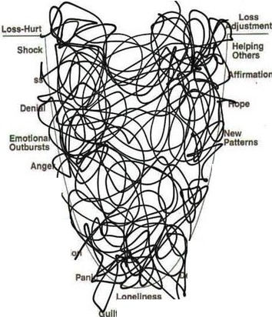
J

Loss-Hurt
Shock Numbness
Oenlal

Emotional Outbursts
Anger

Fear
Loss
Adjustm<1nt
Helping Others
Afflrmatlon Numbne Hope
New Patterns

New Strengths

New

Fea

New Strangths

New

Searchings

Disorganization

Panic

Loneliness
Relatlonshlps

"Re'Entry•
Troubles
Oepresslon

Searchings

Olsorganlzall
Relallonshlps

'Re-Entry• Troubles
prasslon

Guilt Isolation
lsolatlo

